**Credit One Customer Default Identification Report**

**By Omar Chavez**

**1/24/2022**

**How To Ensure That Customers Can/Will Pay Their Loans**

During the exploratory data analysis, some patterns were identified in the data that can help us identify customers that will not default.

For example, the chart below illustrates default rates when compared to education level. This chart shows us that, excluding ‘Other Education’, default rates are inversely related to education level. Which is to say, that default rates are highest in people with only a high school education, and are lowest in people with a graduate level degree.

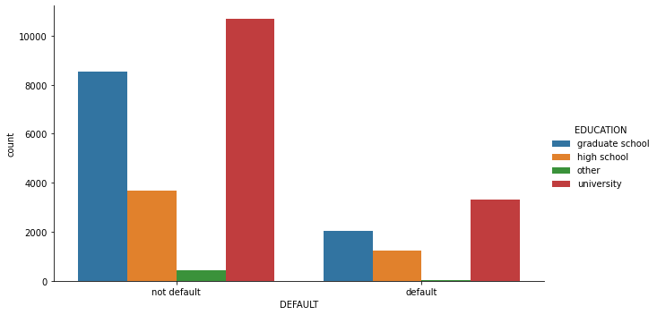

Figure : Comparing Education Level to Default Rates

Another interesting observation made was that default rates were highest in people that were divorced (26%) as opposed to married individuals (20.95%), and single/unmarried individuals (23.46%). Figure 2 below illustrates this phenomenon.

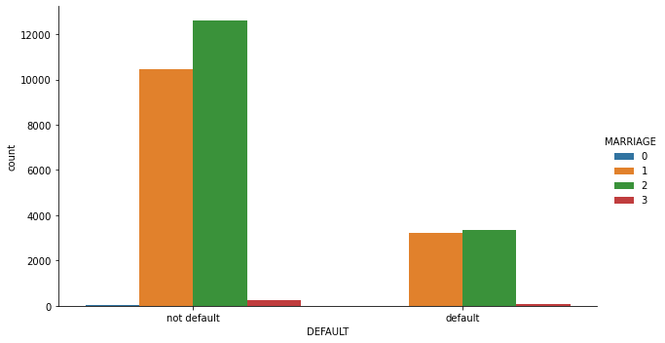

Figure : Default Rates Compared to Marriage Status. 1 = Single. 2 = Married. 3 = Divorced

Another interesting find was found when default rates were compared to balance limits.

Default rates go down as limit balance increases. Default rates are especially high in the first bucket of $9,999-$50,000. This is very significant. There needs to be more scrutiny done on people that apply for loans in this range.

Table : Default Rates at Each Balance Limit Level

|  |  |
| --- | --- |
| Balance Limit | Default Rate |
| $9999-50,000 | 31.79% |
| $50,000-100,000 | 25.82% |
| $100,000-180,000 | 19.87% |
| $180,000-270,000 | 16.87% |
| $270,000-1,000,000 | 13.77% |

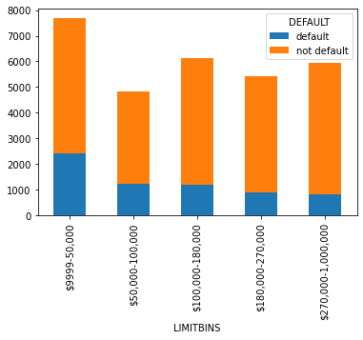

Figure : Balance Limits Compared to Default Rates

Finally, default rates were compared to age. The findings are shown in Table 2 below. Default rate is highest in younger people and in the highest age bracket. It makes sense that the younger people would default more, but why do people aged 43-79 default more? This is something that should be examine further.

Table : Default Rates at Different Age Ranges

|  |  |
| --- | --- |
| Age Range | Default Rates |
| 20 – 37 | 24.21% |
| 27 – 31 | 19.62% |
| 31 – 37 | 20.52% |
| 37 – 43 | 21.70% |
| 43 -79 | 24.33% |

**Can Customers Be Approved with High Certainty**

After running three different predictive algorithms, there was an algorithm that achieved 77% accuracy in being able to take a customer and predict whether that customer defaulted or not. This algorithm takes into account the trends pointed out above and determines if a customer will be credit worthy by looking at the past behaviors and patterns that we have discussed above. And because of the unpredictability of humans as individuals, the algorithm only had a 77% success rate. There will always be risk in lending to people, simply because of the nature of people and they’re innate unpredictability.